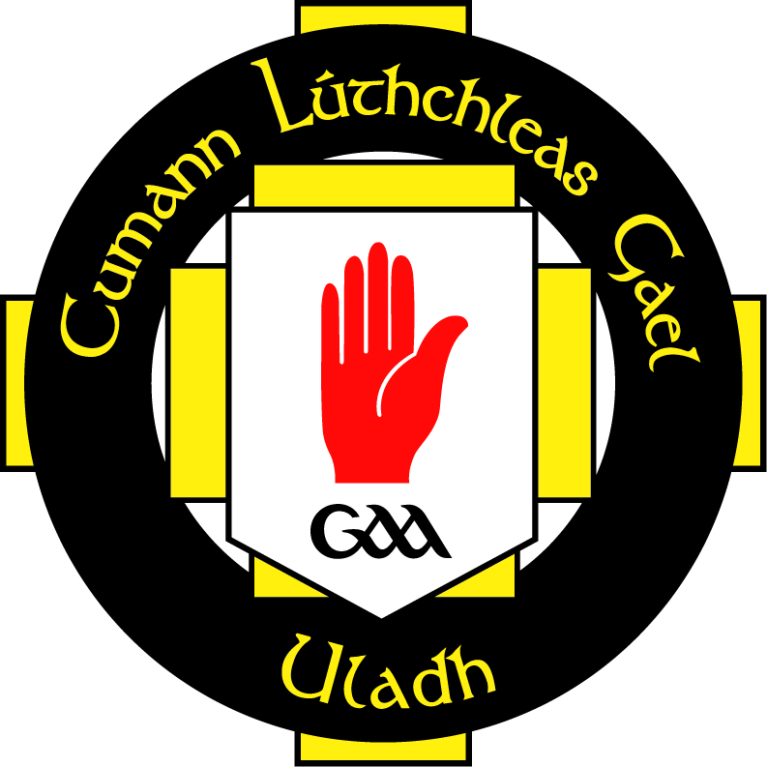

AccessNI
Parent/Guardian Consent Form

I _______________________

Of __________________________________________________________
_____________________________________________________________
(Address)

Being the ______________________
Mother/Father/Guardian

Of _____________________________
Name of Application for AccessNI

Date of Birth ______________________

do hereby consent for AccessNI to conduct a vetting check in respect of the above named and to furnish Ulster GAA, a registered Umbrella Body with AccessNI, with a statement that there are no convictions recorded against him/her.

Signed: ________________________________

Date: ____________________________

